# About the Ethical Standards Commissioner

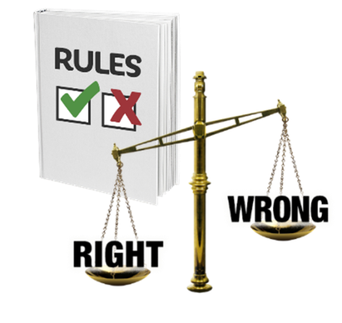

If you need this document in another format like large print, audio or Braille please contact us:

* call 0300 011 0550
* email: [info@ethicalstandards.org.uk](mailto:info@ethicalstandards.org.uk)
* or do it online at: [www.ethicalstandards.org.uk/contact-us](http://www.ethicalstandards.org.uk/contact-us)

Copyright images @ Photosymbols. Prepared by The Ethical Standards Commissioner 

## What does the Ethical Standards Commissioner do?

|  |  |
| --- | --- |
| a set of scales with 'right' weighing heavily and 'wrong' weighting lighter, next to a rulebook with a green tick and a red cross on the cover. | **Ethical standards** are the rules about what is right and wrong.  It means for example treating people the way you would like to be treated. |
| a man writing on a checklist and a woman looking closely at things.  a man complaining to a woman who is writing information on a notepad | We check **complaints** about the conduct of:   * + Members of the Scottish Parliament (MSPs)   + local councillors   + and **board members** of **public bodies.**   A **complaint** is when a person says or writes that they are not happy about something. |
| 5 seated people at a Board meeting round a table | **Board members** look at the work an organisation is doing and check it is working well and following the rules. |
| a group of staff including a social worker and health staff | **Public bodies** are organisations that work for the Government and give us public services**.** Examples of this include the police and health services. |
| a man and woman talking and listening next to party manifestos and rosettes | We investigate **lobbyists** who have not put their name on a Government list.  A **lobbyist** is a person or group who tries to get an MSP to support a policy or campaign. |
|  |  |
| a worried man on the phone | We investigate information from **whistle-blowers.**  A **whistle-blower** is a person who reports information about an organisation doing things that are against the law or are not safe. |
| 5 seated people at a Board meeting round a table | We check how Scottish Ministers make **public appointments**.  A **public appointment** is when a Scottish Government Minister appoints someone to the board of a public body.  We check that people get these roles fairly. |
|  | We make a **Code of Practice** for Ministerial Appointments to Public Bodies in Scotland.  The **Code of Practice** is a set of rules about how to appoint someone to the board of a public body in a fair way.  We want to make changes to this Code to make it better. |
| a thinking woman next to a document with the title 'guidance' and a signpost on the cover  a group of people  a woman complaining to a man, next to a rulebook with a red line through it. | We give guidance and support to Scottish Ministers and boards to make sure they treat everyone who applies to be a board member fairly and boards are **diverse**.  **Diverse** means having a mix of different kinds of people:   * men and women * young and old people * people of different ethnic backgrounds * people from both poor and more wealthy backgrounds * disabled and non-disabled people.   We investigate complaints when people or organisations have not followed the rules in the Code of Practice.  We tell the Scottish Parliament when this happens. |

|  |  |
| --- | --- |
| What we believe in | |
| a set of scales with 'right' weighing heavily and 'wrong' weighting lighter, next to a rulebook with a green tick and a red cross on the cover. | We will do all our work in an ethical way following the rules of what is right and wrong. |
| money - coins and notes and a finger pushing buttons on a calculator | We will spend money in a good way. |
| a man and woman talking and listening | We will be honest and open about what we do. |
| a woman shaking hands with a woman who is a wheelchair user | We will treat every person and organisation that contacts us with kindness and respect so they can trust us. We will treat everyone fairly. |
| a thinking man with a thumbs up and a thumbs down in thought bubbles above his head. | We will tell people when we get things wrong.  We will show what we have learned and make our work better. |

## What we want to do

|  |  |
| --- | --- |
| 3 staff giving the thumbs up | We will make sure we have the people, money and things to do our work. |
| a man complaining to a woman who is writing information on a notepad | We will have a good complaints **system** that:   * + works well   + helps us to learn   + makes sure people who work in public service have high standards.   A **system** is a way of doing something that follows a set of rules. |
| 2 groups of people meeting and talking - 2 of them are shaking hands. | We will tell people about our rules and how we do our work. |
| a rulebook with a green tick and red cross on the cover, next to a document with the title 'work policy'. | We will use the information they give us to make our work fairer and better. |
| a group of people | We will help to make sure boards are diverse and look like the communities they work with. |