Questions and Answers about Public Appointments

Easy Read

Copyright images @ Photosymbols. Prepared by The Ethical Standards Commissioner

What is a public appointment?

A public appointment is when a Scottish Government Minister appoints someone to the board of a public body.
A board and its members look at the work an organisation is doing and check it is working well.

Public bodies are organisations that work for the Government and give us public services.

Public services are services we all use like the Scottish Government, schools, hospitals and councils.

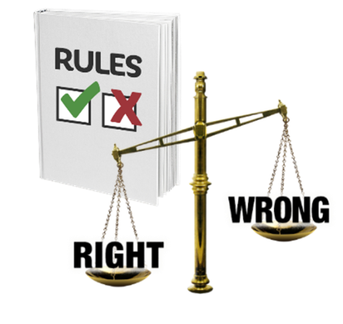 | Some public appointments are regulated by the Ethical Standards Commissioner.  Regulated means that something has rules that need to be followed.
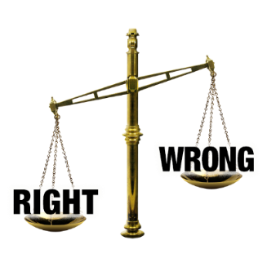 | The law decides if a public appointment is regulated or not.
 | You can see a list of public bodies that are regulated on our website: https://www.ethicalstandards.org.uk/regulated-bodies

What does the Ethical Standards Commissioner do?

 | The Ethical Standards Commissioner checks how Scottish Ministers make public appointments.
The Commissioner and their team are independent.
Independent means they do not work for the Scottish Parliament or Scottish Government.

We make a Code of Practice for Ministerial Appointments to Public Bodies in Scotland.
The Code of Practice is a set of rules about how to appoint someone to the board of a public body in a fair way.

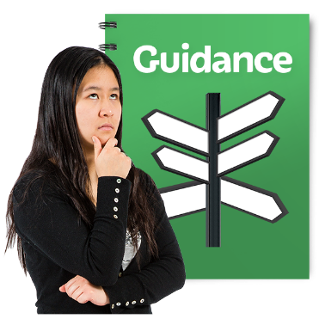 | We give guidance and support to Scottish Ministers and boards to make sure they treat everyone who applies to be a board member fairly and boards are diverse.  Diverse means having a mix of different kinds of people:  • men and women  • young and old people  • people of different ethnic backgrounds  • people from both poor and more wealthy backgrounds  • disabled and non-disabled people.
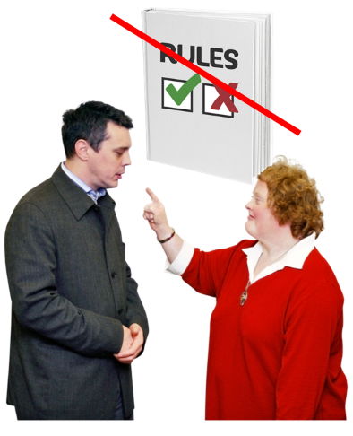 | We investigate complaints when people or organisations have not followed the rules in the Code of Practice.  A complaint is when a person says or writes that they are not happy about something.  We tell the Scottish Parliament when this happens.
 | The Ethical Standards Commissioner does not do any of the work to appoint board members.
 | The work to appoint board members is done by the Scottish Government. This is called an appointment round.

What happens when I apply for a regulated appointment?
The Code of Practice says that you should feel respected if you apply for an appointment.
Respected means being treated politely and given all the support you need.

The Ethical Standards Commissioner wants you to have a good experience even if you do not get the appointment.
Every appointment round will be different. This is because different public bodies need different people.

But to make sure you have a good experience there are some things that will happen in every appointment round.

Every appointment round will have an applicant pack. This is made by the panel.
The applicant pack has all the information you will need to apply for the appointment.

A panel is a group of people who test the people who apply for the appointment.

Scottish Ministes choose who the panel members will be.

The applicant pack will include a list of all the important dates during the appointment round. This will include interview dates so that you can plan your time.

An interview is where you meet with the recruitment panel. At the appointment you can tell them why you would be a good person for the appointment.

If you apply for a public appointment you will be tested against a person specification that has been made by the recruitment panel.
A person specification is a list the things the person who gets the appointment must be able to do.

The panel will not test anything that is not on the person specification.
The panel will also do some other checks to make sure you are right for the appointment. This is called a fit and proper person test.
A fit and proper person test is another way the panel make sure you are the right person for the role. It checks whether anything you have done now or in the past makes you not right for the role. For example, the panel will make sure that the time needed to do the role is something you can do.

You can ask for any reasonable adjustments during the process.
A reasonable adjustment is changing the way something is done to make sure everyone can take part. An example of this might be more time for tests or interviews.

If you need to ask for a reasonable adjustment, use the phone number or email address in the pack.

Sometimes the Scottish Minister will want to meet short-listed candidates.
Short-listed means when someone has passed the test for appointment.

But this will not always happen.

If you get the appointment then your name will be put on the Scottish Government website to let people know: https://www.gov.scot/collections/public-appointments-announcements/

Public Appointment Advisers

The Ethical Standards Commissioner and their team are helped by a group of Public Appointment Advisers.

Public Appointment Advisers are a group of people who help with the work of the Ethical Standards Commissioner.

Public Appointment Advisers work with panel members to make sure they do what the Code of Practice says they should do.

Sometimes Public Appointments Advisers will become a full panel member.

And sometimes they will take part for just some of the process. For example, they might help the panel to make the appointment plan.

